Dear Bert and Aaron,

Tim, Greg, Sara Miller and I had a teleconference Thursday in which Sara and I expressed our concern with using the maximum allowable exploitation rate of 20% as described in the Bristol Bay Herring Management Plan (5 AAC 27.865) for the Togiak herring fishery in 2019. There has been increasing uncertainty in our forecasts due to lack of usable aerial survey estimates the last three years and we believe that the uncertainty in our forecast is great enough to warrant consideration of reducing the harvest rate.

Aerial survey biomass and estimates of age composition and weight at age from fishery samples are the inputs to the age-structured (ASA) model. For the last three years (2016-2018) we haven’t been able to obtain an aerial survey biomass estimate that is representative of the biomass of the spawning population, so the ASA model has been run without biomass data for these years. Although we don’t have error estimates for our ASA forecasts to quantify this, the more years we go without key data inputs, the more uncertain our forecasts undoubtedly become. With a few years of missing data like we currently have, the forecast may be dramatically different than one would be with recent biomass information, so we are concerned with using a maximum 20% harvest rate.

There are many options for a lower harvest rate, but one would be to decrease the harvest rate by 2% times the number of years since the last aerial survey estimate. So, if there was an acceptable aerial survey estimate in a given year, the harvest rate for the next year would be the maximum 20%. After five years with no biomass input the harvest rate would be 10%, and after 10 years without an input the harvest rate would be zero. For 2019, this would result in a harvest rate of 14%. The reason I suggest something progressive is because whether we get a useable aerial survey biomass estimate in a particular year is often outside of our control due to weather conditions, let alone limits in budgets and staff time. So we will continue to face years, and sometimes multiple years, without useable aerial survey biomass estimates, where we will need to decide whether to reduce the harvest rate and how much (or to even run a forecast at all??). Adopting a progressive method may be better than having to decide on an annual basis. This is only one idea for how a harvest rate could be adapted over time and there are certainly many others. Given current harvest policies around Alaska and British Columbia, however I do not believe 14% is any too conservative given our forecast is made without population biomass information from the last three years.

There is precedent in ADF&G herring management for being more conservative when uncertainty is greater. For instance, in Southeast Alaska, if a survey biomass estimate and survey age compositions are not collected in a particular year, there is no forecast made for the following year and the fisheries are closed. There is also precedent for taking management action to lower the harvest rate when there are particular concerns about the forecast. For the 2008 Sitka GHL, despite that the Sitka GHL calculation is specified directly in regulation, the Sitka manager reduced the harvest rate when he felt it was necessary for conservation and the action was later commended by the Board of Fisheries. It does not appear to me that we are constrained in regulation to a 20% harvest rate in Togiak due to it being described as a maximum allowable exploitation rate, but this may be a question for the Department of Law.

Recent environmental changes in the Bering Sea provide additional reason for concern when harvesting Togiak herring without recent aerial survey biomass data. Without recent biomass estimates, the ASA model uses survey biomass levels from previous years (2015 and earlier) to “anchor” the model biomass trend. Annual age composition data is used to “adjust” the trend up and down (e.g. if samples show lots of young fish, the forecast will increase because of these additional fish and if we see few, the biomass will decrease). However, the trend will only be representative of the population if natural mortality remains constant, because age composition data alone cannot detect increases and decreases in mortality that affect all age classes similarly. The following citations from the minutes of the October 2018 Scientific and Statistical Committee of the North Pacific Management Council (<https://www.npfmc.org/meeting-minutes/> and click on “October 2018”) summarize Bering Sea research observations from the last year, which suggest that environmental conditions may be changing enough to affect herring survival:

* “Conditions in the Bering Sea during 2018, and in particular, the Northern Bering Sea (NBS) have been extraordinarily different than in past years.”
* “There was little or no sea ice present in the NBS and Chukchi in winter 2017/2018, and what there was arrived late in the season (March) and departed early (April).”
* “[There was] an unprecedented reduction in the cold pool (1% of its average extent)[in the eastern Bering Sea in 2018].”
* “Water temperatures, particularly at depth, were warmer than usual, and there was no cold pool on the eastern Bering Sea shelf.”
* “The reduced extent, quality, and duration of sea ice and the warm ocean temperatures were unprecedented.”
* “The lack of sea ice meant that ice algae were not available in winter and early spring to support the production of zooplankton, particularly large, lipid-rich species that are important for fish and seabirds.”
* “There was a sharp, notable drop in [young] herring biomass as measured by the BASIS survey.” See following figure.

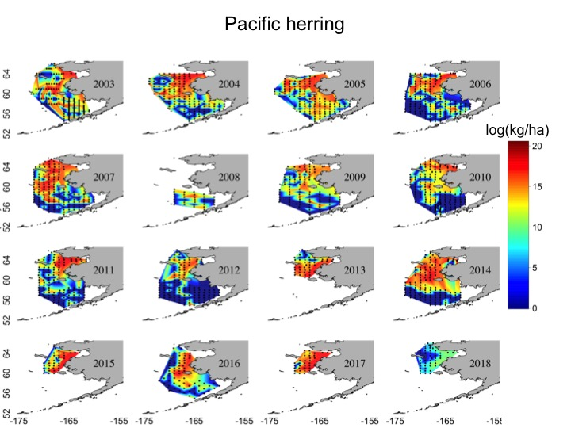

While we do not know how recent Bering Sea changes have and will affect the Togiak herring population, the fact that unprecedented changes are occurring further support the idea that more conservative management in times of limited information on Togiak herring population size may be warranted.

The Board of Fish proposal to increase the allocation of the Togiak GHL to the seine fishery is also pertinent to the discussion of harvest rates. Since the gillnet fleet has not taken their allocation in recent years, the realized harvest rate in Togiak has been less than 20%. If the allocation stays the same and you choose to decrease the target harvest rate from the 20% maximum, the realized harvest rate will be less than it has been in recent years. If the Board of Fisheries changes the allocation and you choose to keep the maximum 20% harvest rate, the realized harvest rate would actually increase. If the Board of Fisheries changes the allocation and you choose to decrease the target harvest rate, the realized harvest rate might stay about the same. So it is certainly worth taking into consideration the possible results of the current Board of Fish proposal when choosing the target harvest rate for the upcoming year.

Thanks for your consideration.